**Locus of evader coordinates with same evader velocity and same interception point***:*

Let evader be at, target at, pursuer at 

Let the velocity of the evader to the velocity of the pursuer ratio be 

The expressions for centre and radius of the corresponding Apollonius circle are

 (1)  (2)

 (3)

Equation of Apollonius circle is 

Let the corresponding interception point be.

Objective is to find the set  that result in.

For  to be the interception point of any other circle, it has to be the nearest point to the target by definition. So the centres of all Apollonius circles for which  is the interception point must lie on the line joining target  and. So the following condition will hold.

=  (4)

*Where* is the centre of any Apollonius circle whose interception point is.

lies on.

Substituting corresponding expressions of,  in (4),

 (5)

Simplifying,

*L:*  (6)

So all the evader initial positions which result in same interception point  for constant *k* lie on the line with slope equal to the slope of.

But this equation is also satisfied by all the evader coordinates whose corresponding interception points lie on, as is obvious from (4).

Note that interception point has to lie on all Apollonius circles for which it is interception point.

This means  (7)

Substituting corresponding (1), (2), (3) in (7)



Solving we get the following circle equation.

  (8)

*C* is the set of all evader coordinates whose corresponding Apollonius circles pass through 

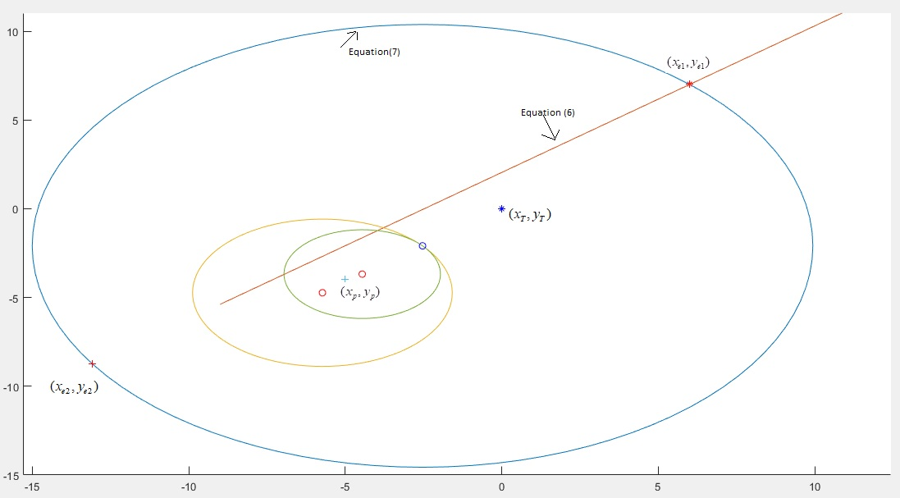

Fig 1. The game geometry with all the possible evader positions and corresponding Apollonius circles

Solving *C* and *L* means that we are finding all the evader coordinates whose corresponding Apollonius circles with their centres lying on, pass through. Hence the solution set can also include the cases which are infeasible, cases where the centres of Apollonius circles which pass through, lie on, but their interception points lie on the diametrically opposite end as in fig 2.

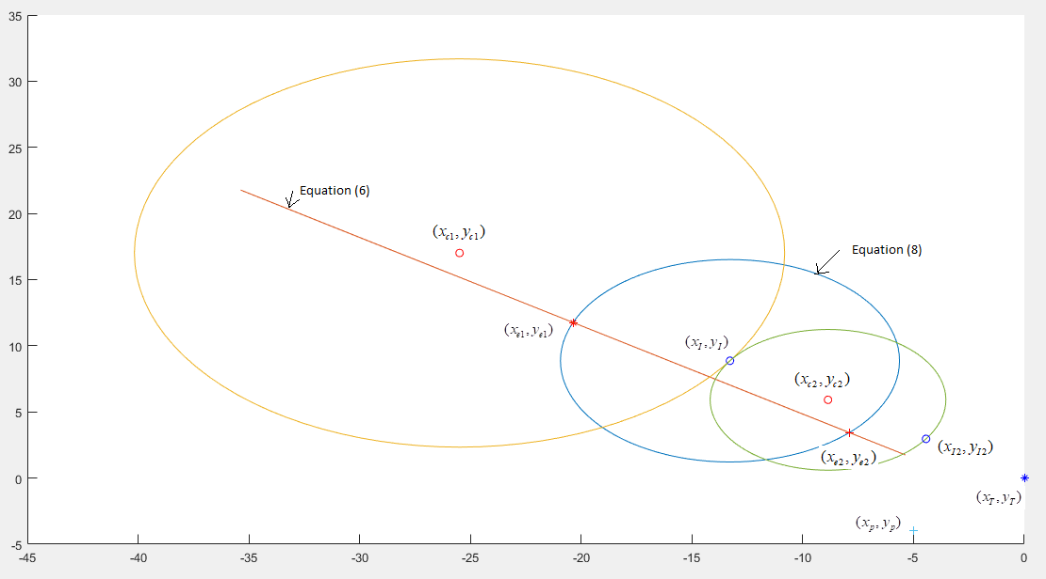

Fig 2. Infeasible case where satisfies equations (6) & (8) but still its corresponding interception point is not 

**Locus of evader coordinates with different evader velocities and same interception point***:*

Objective is to find the set  that result in.

Equation (5) changes to

, 

, Where 





 (9), where 

And equation (8) becomes  (10)

Substituting  from (9) in (10), 

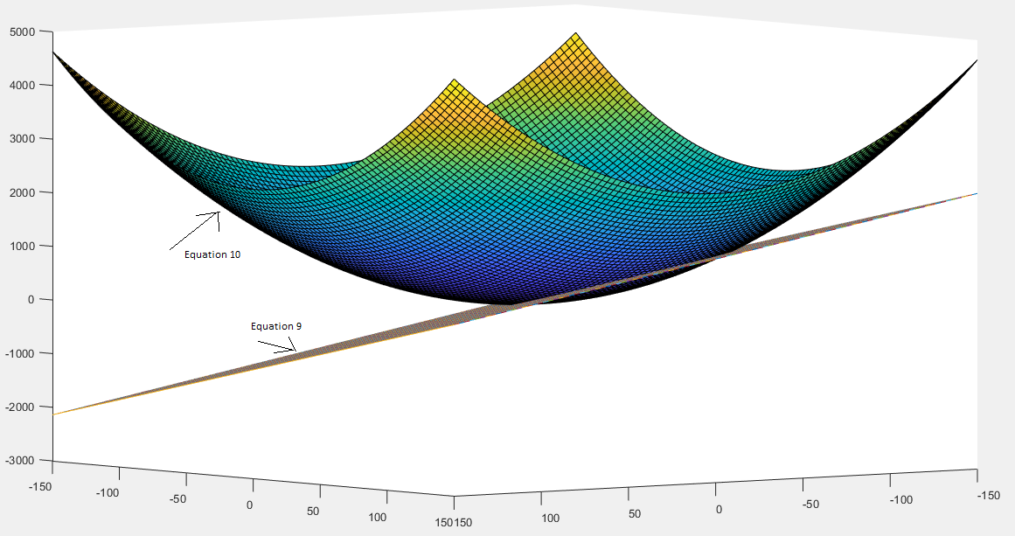

Fig 2. for same interception point will be intersection of paraboloid and a plane (with  considered as z)

Let  be *L*

Rearranging the terms,  (11)

where, , 

So all  whose corresponding interception point can be  satisfy (11) and corresponding  lie on (9) 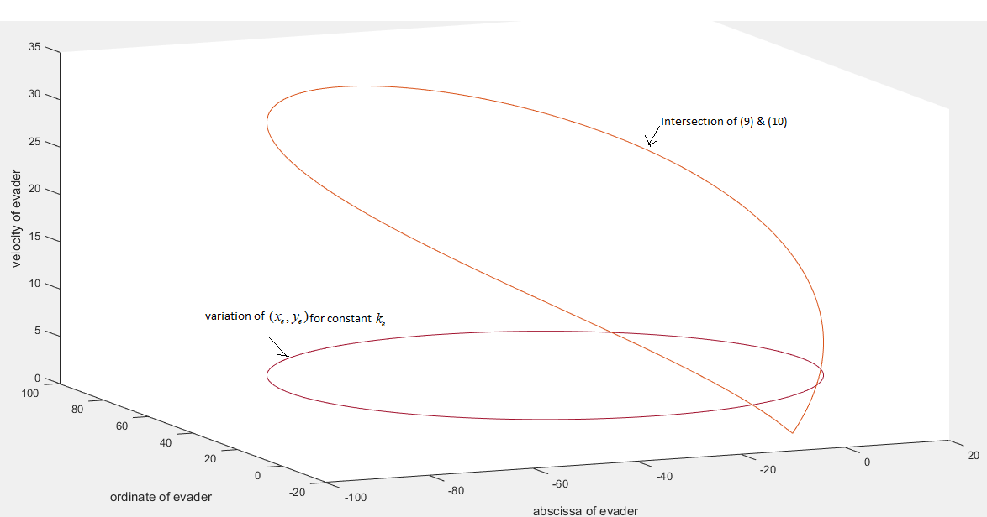

Fig 3. 